**EXERCISE -** 6

**CLASSES**

**Aim:** Write a java program to demonstrate Abstract class.

**File name:** Abstract.java

**Program:**

**import java.lang.*;**

**import java.util.Scanner;**

**abstract class shape{**

**int l,b,h;**

**Scanner s = new Scanner(System.in);**

**abstract void printArea();**

**}**

**class Rectangle extends shape {**

**void printArea() {**

**System.out.println("Enter Lenght & Breadth:");**

**l = s.nextInt();**

**b = s.nextInt();**

**System.out.println("Area of Rectangle:"+(l+b));**

**}**

**}**

**class Square extends shape {**

**void printArea() {**

**System.out.println("Enter side:");**

**l = s.nextInt();**

**System.out.println("Area of Square:"+ (l*l));**

**};**

**}**

**class Tryangle extends shape {**

**void printArea() {**

**System.out.println("Enter Base & Height:");**

**b = s.nextInt();**

**h = s.nextInt();**

**System.out.println("Area of Tryangle:"+((b*h)/2));**

**};**

**}**

**class Circle extends shape {**

**void printArea() {**

**System.out.println("Enter Radius:");**

**l = s.nextInt();**

**System.out.println("Area of Circle:"+(3.141*l*l));**

**};**

**}**

**/\*\***

**\* Abstract**

**\*/**

**public class Abstract {**

**public static void main(String[] args) {**

**Rectangle a = new Rectangle();**

**Square b = new Square();**

**Tryangle c = new Tryangle();**

**Circle d = new Circle();**

**a.printArea();**

**b.printArea();**

**c.printArea();**

**d.printArea();**

**}**

**}**

**Output:**

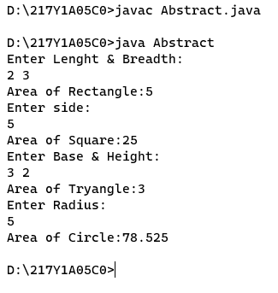

**Aim:** Write a java program to demonstrate Interfaces.

**File name:** Interface.java

**Program:**

**import java.lang.*;**

**import java.util.Scanner;**

**interface Multiplication {**

**public void mul();**

**}**

**class cal implements Multiplication {**

**int a,b;**

**public void mul() {**

**Scanner s = new Scanner(System.in);**

**System.out.println("Enter two numbers:");**

**a = s.nextInt();**

**b = s.nextInt();**

**System.out.println("Multiplication: "+(a*b));**

**}**

**}**

**public class Interface{**

**public static void main(String[] args) {**

**cal obj = new cal();**

**obj.mul();**

**}**

**}**

**Output:**

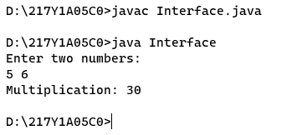

**Aim:** Write a java program to demonstrate Super class.

**File name:** SuperDemo.java

**Program:**

**class Parent {**

**void display() {**

**System.out.println("Parent Method");**

**}**

**}**

**class Child extends Parent {**

**void display() {**

**System.out.println("Child Method");**

**}**

**void show() {**

**super.display();**

**display();**

**}**

**}**

**public class SuperDemo {**

**public static void main(String[] args) {**

**Child c = new Child();**

**c.show();**

**}**

**}**

**Output:**

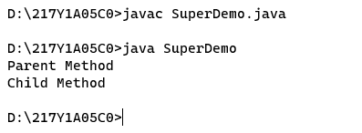

**Aim:** Write a java program to demonstrate Multiple Inheritance.

**File name:** Interface2.java

**Program:**

**import java.lang.*;**

**interface Emp {**

**public void ursalary();**

**}**

**interface Empbonus {**

**public void urbonus();**

**}**

**class tot implements Emp,Empbonus {**

**public void ursalary() {**

**int salary=500000;**

**System.out.println("Salary:"+salary);**

**}**

**public void urbonus() {**

**int bonus=50000;**

**System.out.println("Bonus:"+bonus);**

**}**

**}**

**class Interface2 {**

**public static void main(String args[]) {**

**tot me=new tot();**

**me.ursalary();**

**me.urbonus();**

**}**

**}**

**Output:**

